Feature Selection in Text

Applied Text Mining

Ayoub Bagheri

Table of Contents

## Lecture’s plan

1. How to do feature selection for text data?
2. Is PCA a FS method for text?
3. Other methods?

## An illustration of VS model

* All documents are projected into this concept space

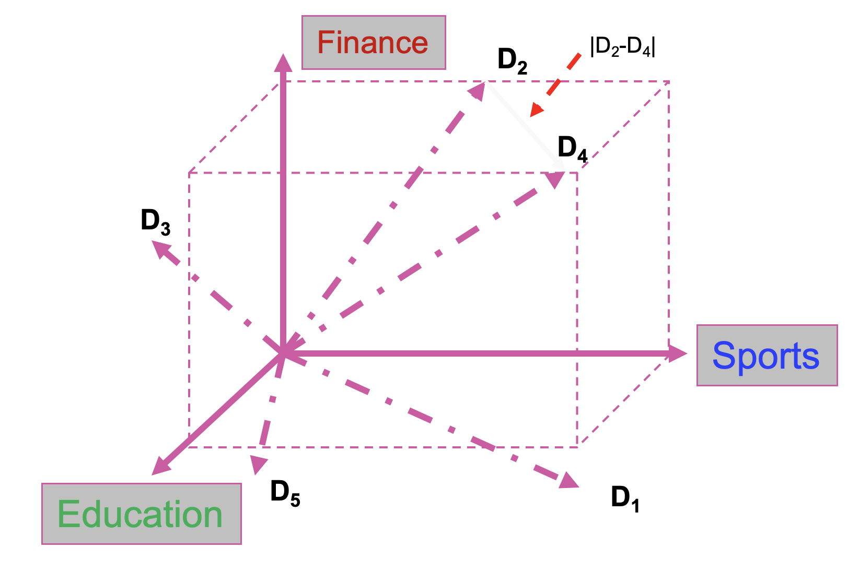

## Feature selection: What

You have some data, and you want to use it to build a classifier, so that you can predict something (e.g. email spam classification)

## Feature selection: What

You have some data, and you want to use it to build a classifier, so that you can predict something (e.g. email spam classification)

The data has 10,000 fields (features)

## Feature selection: What

You have some data, and you want to use it to build a classifier, so that you can predict something (e.g. email spam classification)

The data has 10,000 fields (features)

you need to cut it down to 1,000 fields before you try machine learning. Which 1,000?

## Feature selection: What

You have some data, and you want to use it to build a classifier, so that you can predict something (e.g. email spam classification)

The data has 10,000 fields (features)

you need to cut it down to 1,000 fields before you try machine learning. Which 1,000?

The process of choosing the 1,000 fields to use is called Feature Selection

## Feature selection: Why

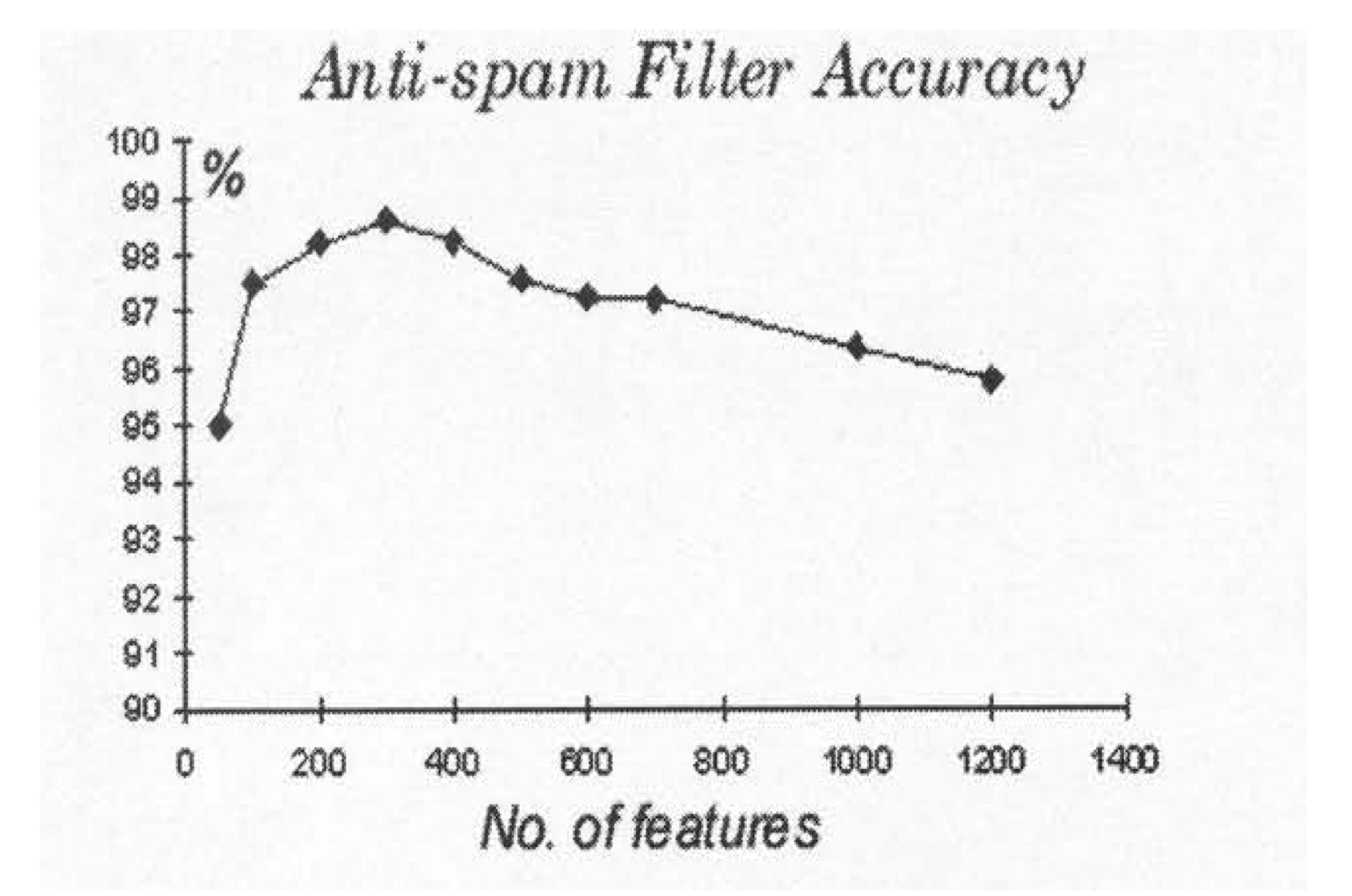

From <http://elpub.scix.net/data/works/att/02-28.content.pdf>

## Why accuracy reduces

* Suppose the best feature set has 20 features.
* If you *add* another 5 features, typically the accuracy of machine learning may reduce.
* But you still have the original 20 features!
* Why does this happen?

## Noise / Explosion

* The additional features typically add *noise*. Machine learning will pick up on spurious correlations, that might be true in the training set, but not in the test set.
* For some ML methods, more features means more *parameters* to learn (more NN weights, more decision tree nodes, etc…)
* The increased space of possibilities is more difficult to search.

## Feature selection

Why we need FS:

1. To improve performance (in terms of speed, predictive power, simplicity of the model).  
  
2. To visualize the data for model selection.  
  
3. To reduce dimensionality and remove noise.

*Feature Selection* is a process that chooses an optimal subset of features according to a certain criterion.

## Feature selection for text

*Feature selection* is the process of selecting a specific subset of the terms of the training set and using only them in the classification algorithm.

* high dimensionality of text features
* Select the most informative features for model training
  + Reduce noise in feature representation
  + Improve final classification performance
  + Improve training/testing efficiency
    - Less time complexity
    - Fewer training data

# Feature Selection Methods

## Feature selection methods

Thousands to millions of features: select the most relevant one to build better, faster, and easier to understand learning machines.

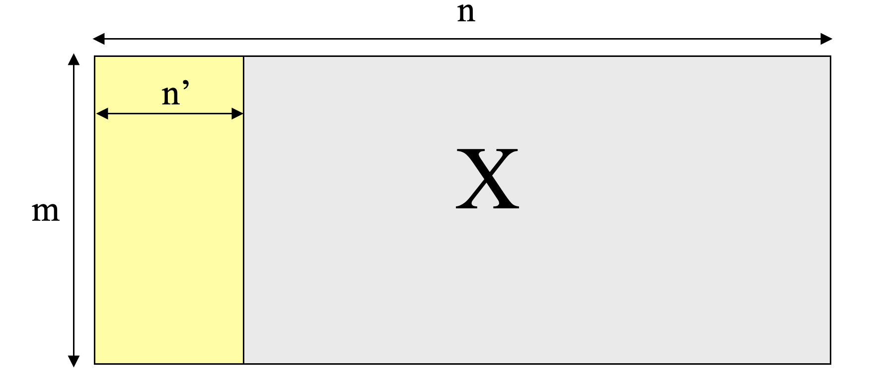

## Filters, Wrappers, Embedded, and Hybrid

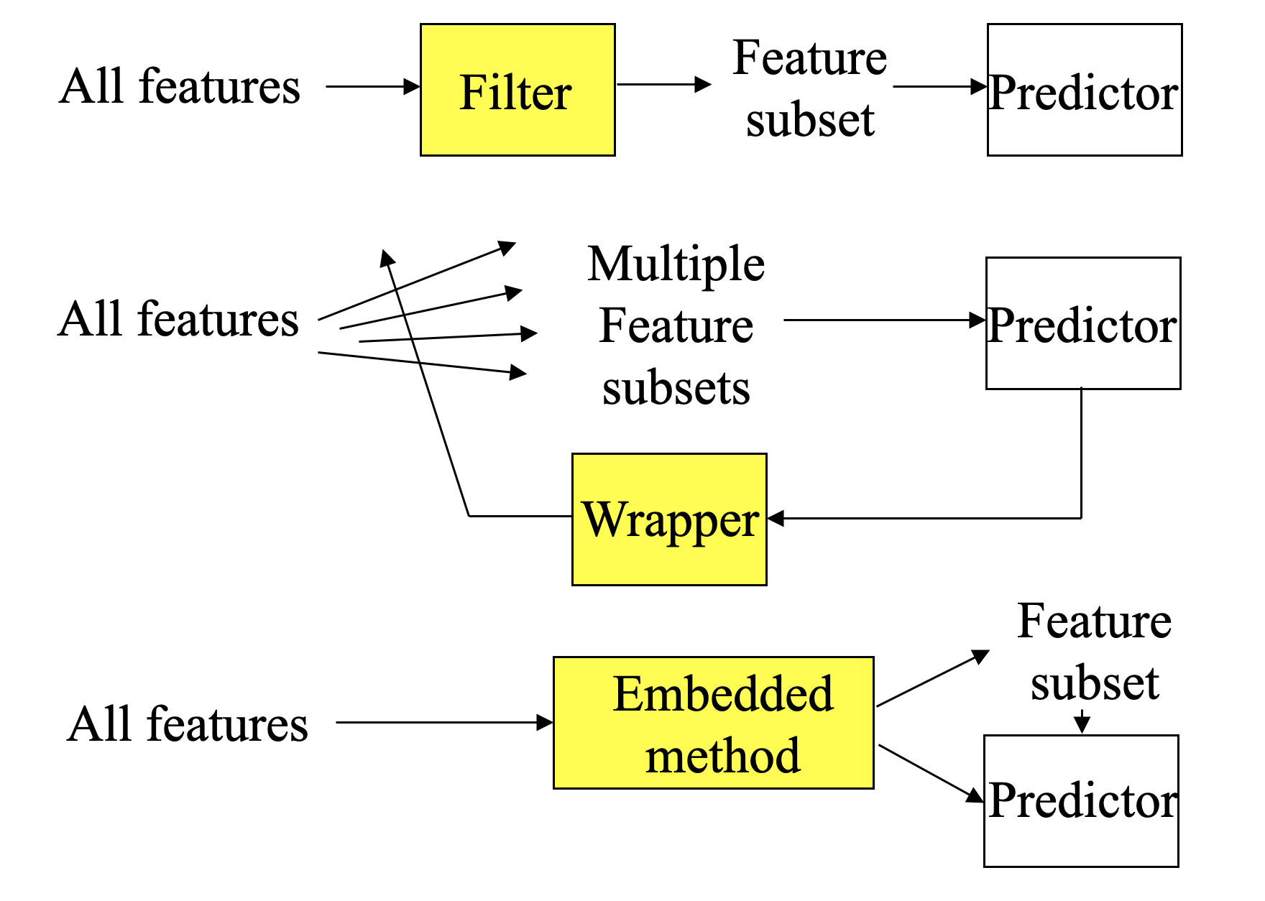

# Wrapper Methods

## Feature selection methods

* Wrapper method
  + Find the best subset of features for a particular classification method

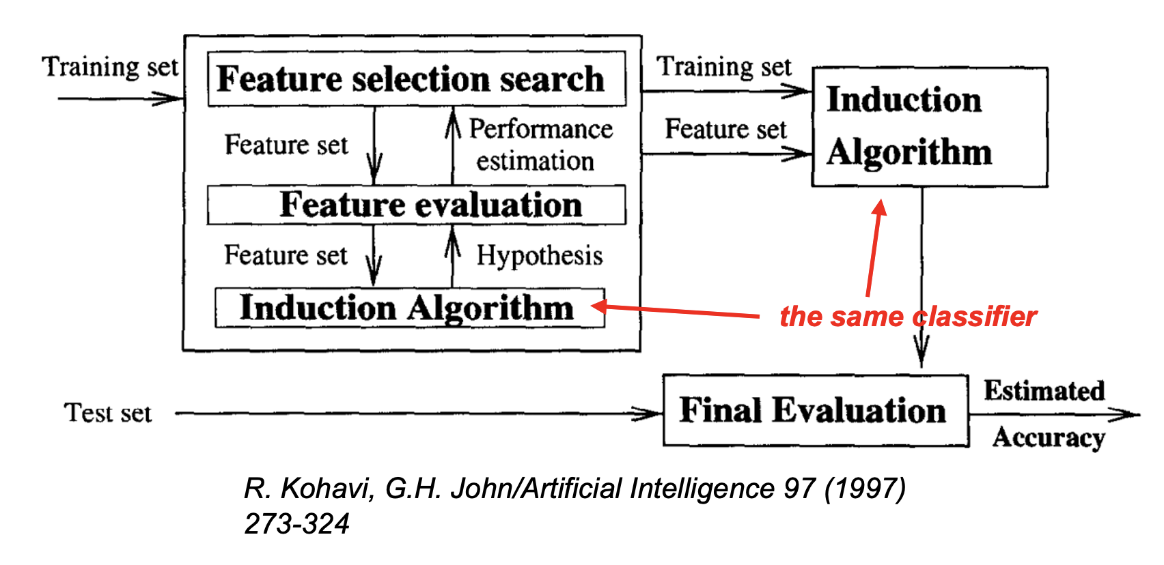

## Feature selection: Wrappers

* Optimizes for a specific learning algorithm
* The feature subset selection algorithm is a “wrapper” around the learning algorithm
  1. Pick a feature subset and pass it in to learning algorithm
  2. Create training/test set based on the feature subset
  3. Train the learning algorithm with the training set
  4. Find accuracy (objective) with validation set
  5. Repeat for all feature subsets and pick the feature subset which led to the highest predictive accuracy (or other objective)
* Basic approach is simple
* Variations are based on how to select the feature subsets, since there are an exponential number of subsets

## Wrapper method

* Wrapper method
  + Consider all possible dependencies among the features
  + Impractical for text categorization
    - Cannot deal with large feature set
    - A NP-complete problem
      * No direct relation between feature subset selection and evaluation

## Wrappers for feature selection

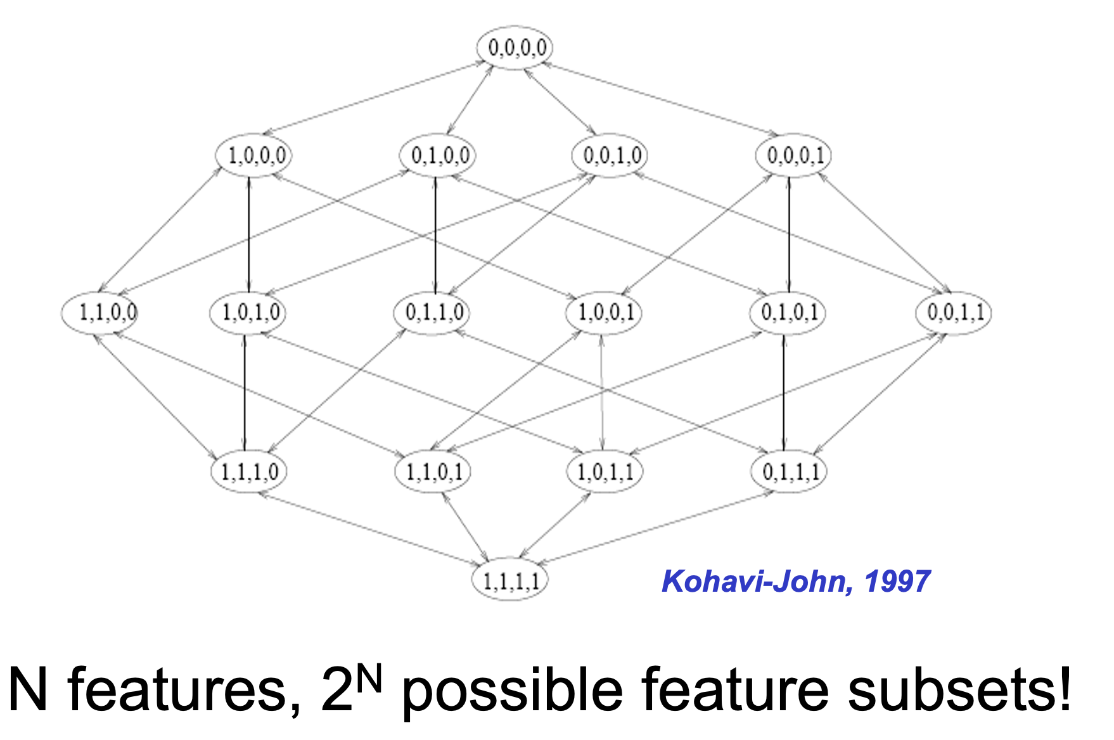

## Search strategies

* **Exhaustive search**
* **Greedy search**: forward selection or backward elimination
* **Simulated annealing**
* **Genetic algorithms**

# Filter Methods

## Filter method

* Filter method
  + Evaluate the features independently from the classifier and other features
    - No indication of a classifier’s performance on the selected features
    - No dependency among the features
  + Feasible for very large feature set

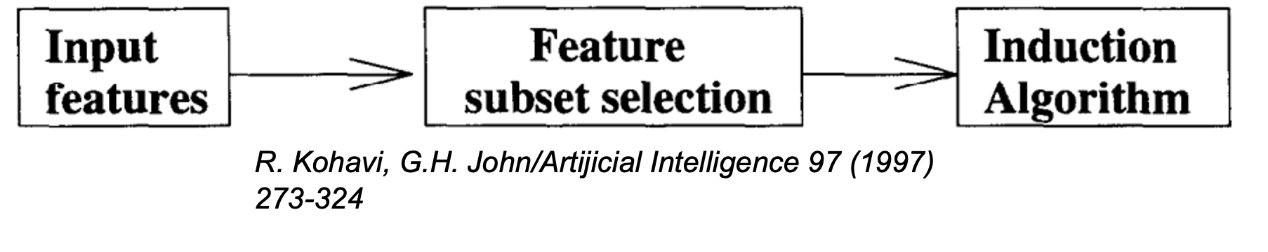

## Document frequency

* Rare words: non-influential for global prediction, reduce vocabulary size

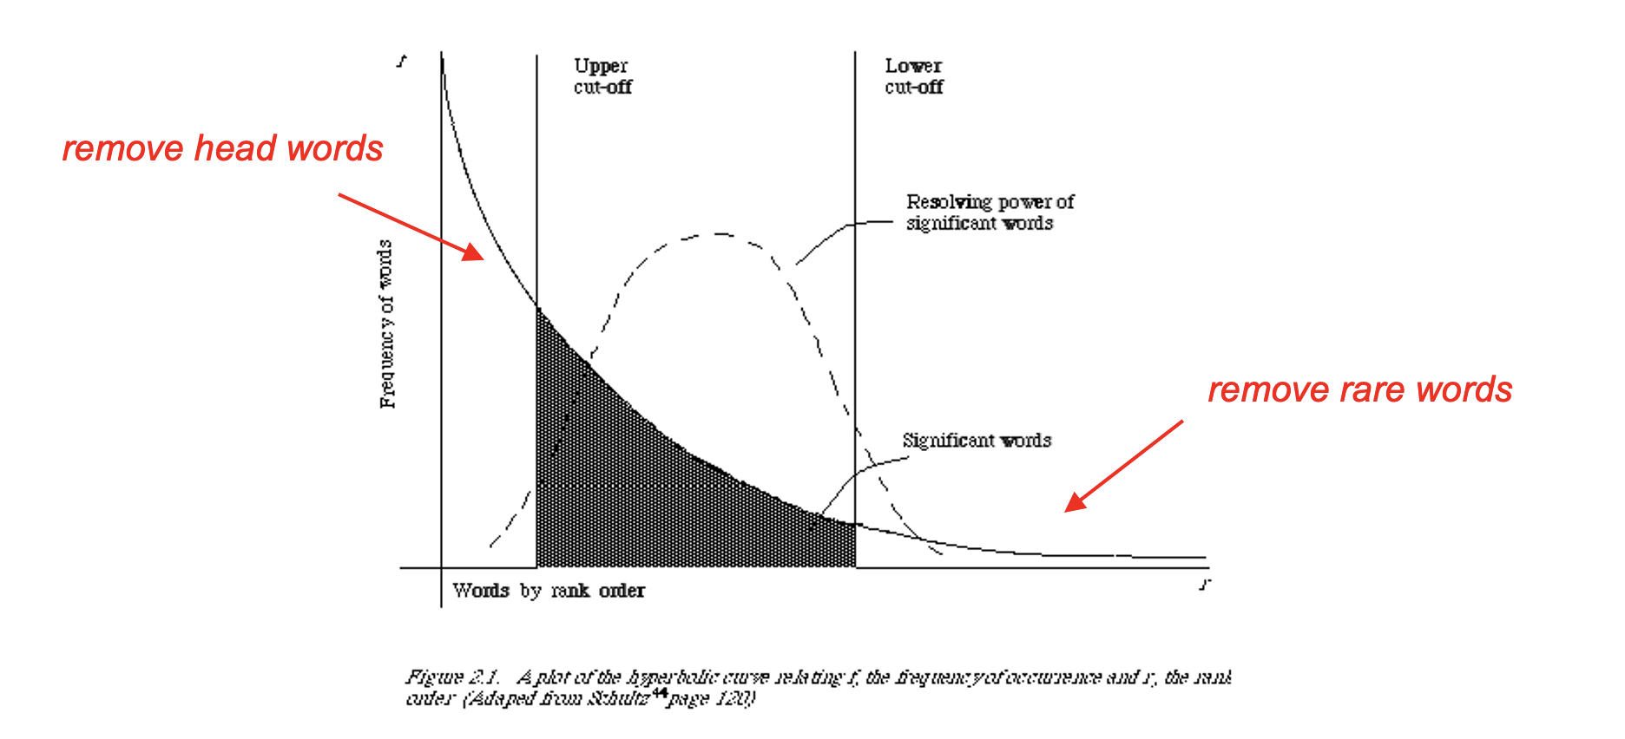

## Information gain

* Decrease in entropy of categorical prediction when the feature is present or absent

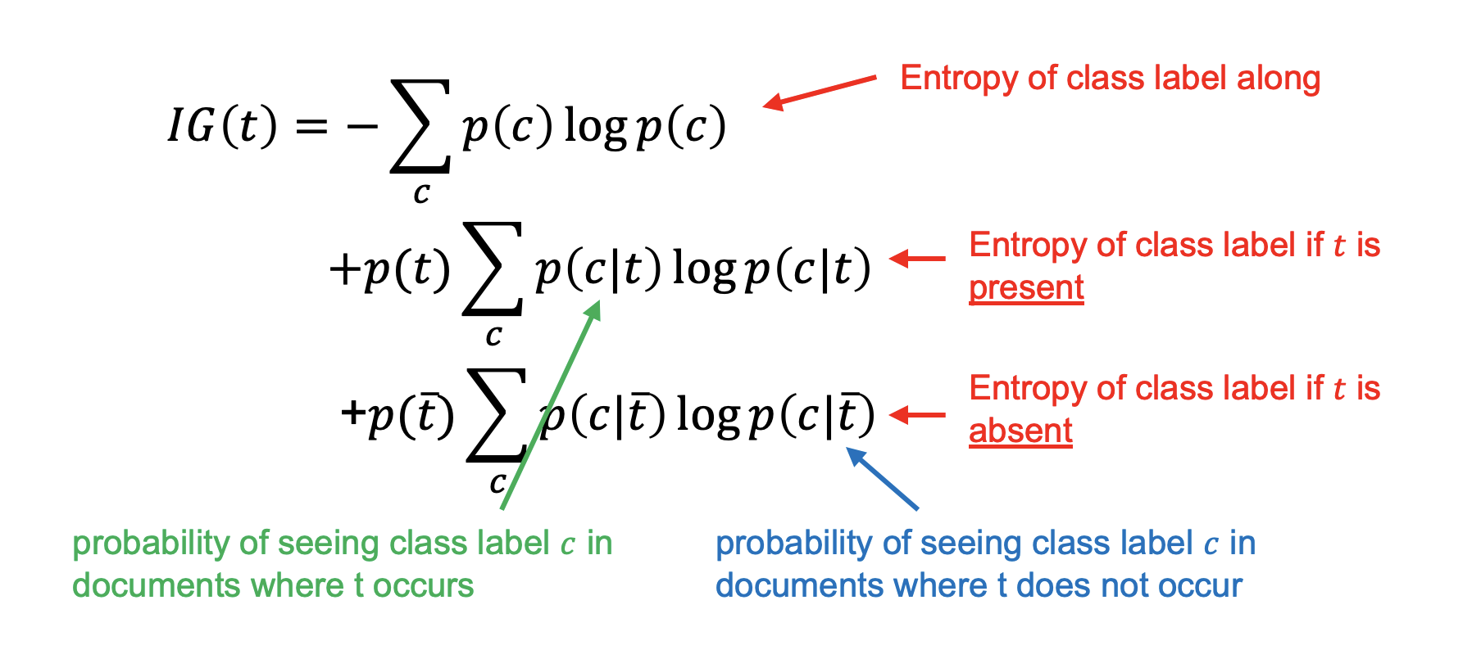

## Gini index

Let $p(c|t)$ be the conditional probability that a document belongs to class $c$, given the fact that it contains the term $t$. Therefore, we have:

$$\sum_{c=1}^{k}{p(c|t)=1}$$

Then, the gini-index for the term $t$, denoted by $G(t)$ is defined as:

$$G(t)=\sum_{c=1}^{k}{p(c|t)^{2}}$$

## Gini index

* The value of the gini-index lies in the range $(1/k,1)$.
* Higher values of the gini-index indicate a greater discriminative power of the term $t$.
* If the global class distribution is skewed, the gini-index may not accurately reflect the discriminative power of the underlying attributes.
* ➔ normalized gini-index

## Feature scoring metrics

* $χ^{2}$ statistics with multiple categories
  + - Expectation of $χ^{2}$ over all the categories
 $χ^{2}(t)=\max_{c} χ^{2}(c,t)$

   - Strongest dependency between a category and a term

## Other metrics

* Many other metrics (Same trick as in $χ^{2}$ statistics for multi-class cases)
  + Mutual information
    - Relatedness between term $t$ and class $c$
 $$PMI(t;c)=p(t,c)log(\frac{p(t,c)}{p(t)p(c)})$$

 + Odds ratio
    - Odds of term $t$ occurring with class $c$ normalized by that without $c$

$$Odds(t;c)=\frac{p(t,c)}{1−p(t,c)}×\frac{1−p(t,\overline{c})}{p(t,\overline{c})}$$

# Embedded Methods

## Formalism

* Many learning algorithms are cast into a minimization of some regularized functional:

$$\min_{α}\hat{R}(α,σ)=\min_{α}\sum_{k=1}^{m}{L(f(α,σ∘x_{k}),y_{k})+Ω(α)}$$

## Formalism

* Many learning algorithms are cast into a minimization of some regularized functional:

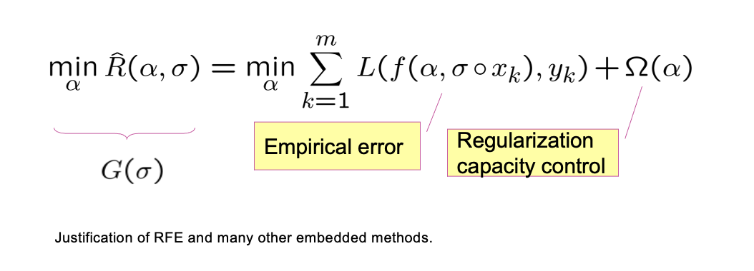

## Lasso vs Ridge

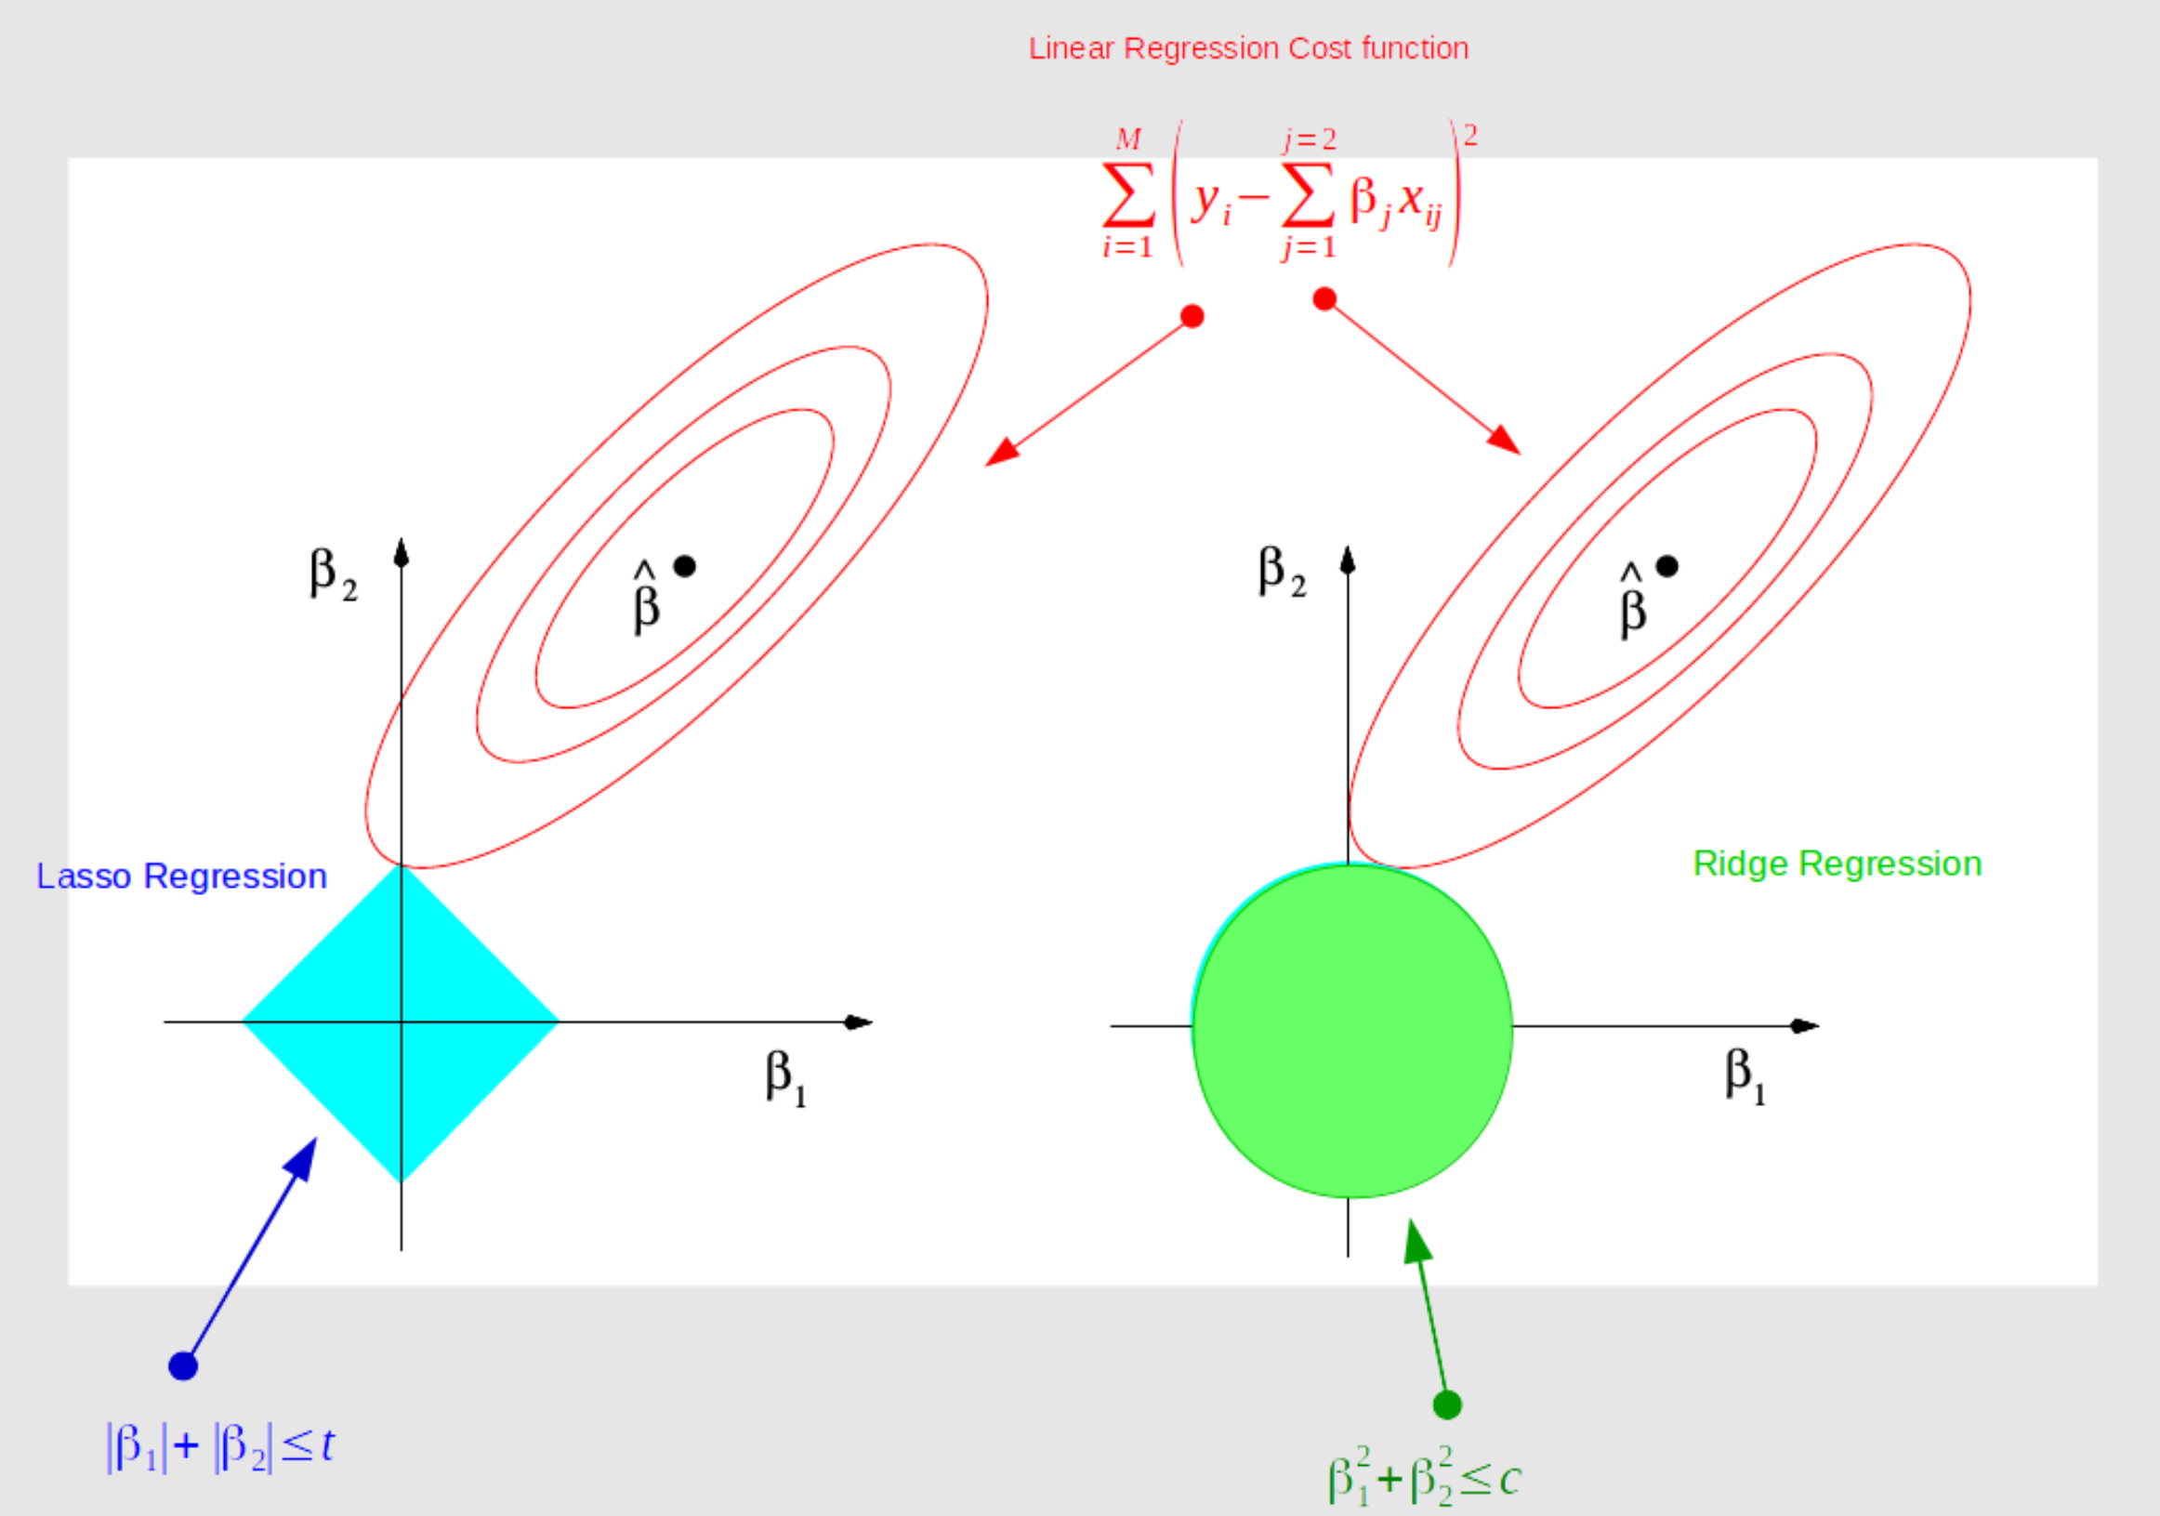

## The $l_{1}$ SVM

* A version of SVM where $Ω(w)=||w||^{2}$ is replaced by the $l_{1}$ norm
* Can be considered an embedded feature selection method:
  + Some weights will be drawn to zero (tend to remove redundant features)
  + Difference from the regular SVM where redundant features are included

## The $l_{0}$ SVM

* Replace the regularizer $||w||^{2}$ by the $l_{0}$ norm $\sum_{i=1}^{n}{1_{w_{i}≠0}}$
* Further replace $\sum_{i=1}^{n}{1_{w_{i}≠0}}$ by
* Boils down to the following multiplicative update algorithm:
  1. Set $σ=(1,...,1)$
  2. Get $w^{*}$ solution of an SVM on data set where each input is scaled by $σ$
  3. Set $σ=|w^{*}|∘σ$
  4. back to 2

## Comparing methods

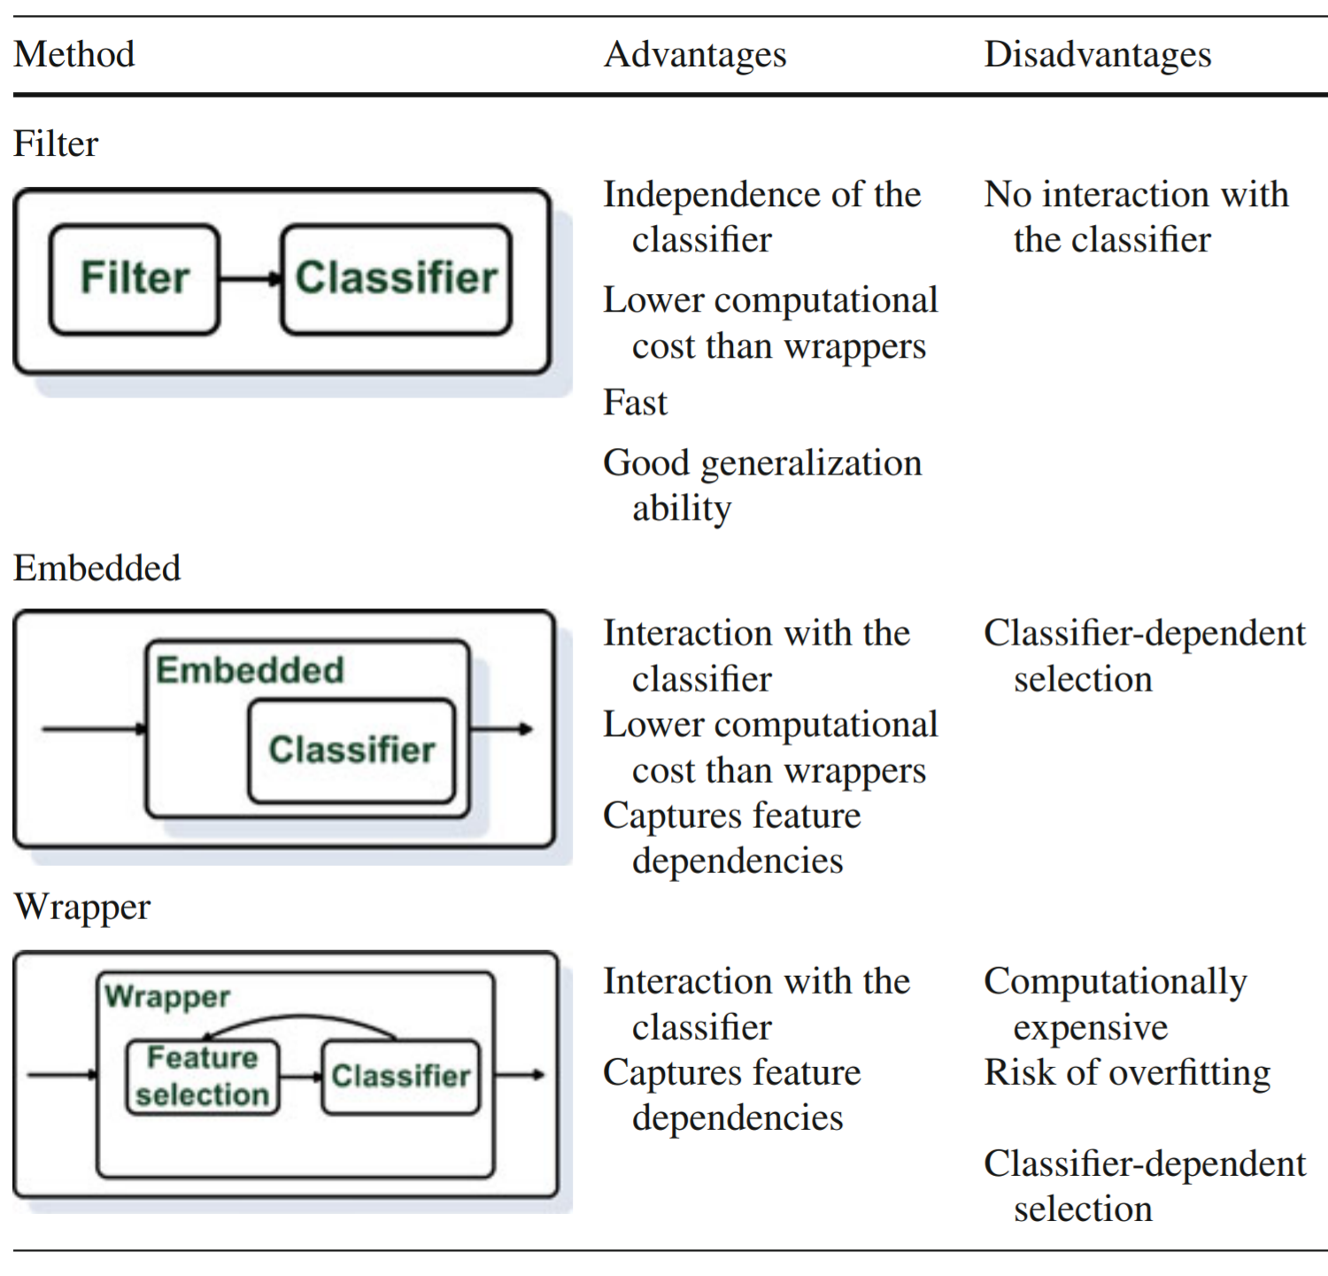

# PCA

## Feature selection vs feature reduction

* *Feature Selection* seeks a *subset* of the $n$ original features which retains most of the relevant information
  + Wrappers (e.g. forward selection), Filters (e.g. PMI), Embedded (e.g. Lasso, Regularized SVN)
* *Feature Reduction combines/fuses* the $n$ original features into a smaller set of newly created features which hopefully retains most of the relevant information from *all* the original features - Data fusion (e.g. LDA, PCA, etc.)

## PCA: Principal Component Analysis

* PCA is one of the most common feature reduction techniques
* A linear method for dimensionality reduction
* Allows us to combine much of the information contained in $n$ features into $p$ features where $p<n$
* PCA is *unsupervised* in that it does not consider the output class/value of an instance – There are other algorithms which do (e.g. Linear Discriminant Analysis)
* PCA works well in many cases where data have mostly linear correlations

## PCA overview

* Seek new set of bases which correspond to the highest variance in the data
* Transform $n$-dimensional *normalized* data to a new $n$-dimensional basis
  + The new dimension with the most variance is the first principal component
  + The next is the second principal component, etc.
  + Note $z_{1}$ combines/fuses significant information from both $x_{1}$ and $x_{2}$
* Drop dimensions for which there is little variance

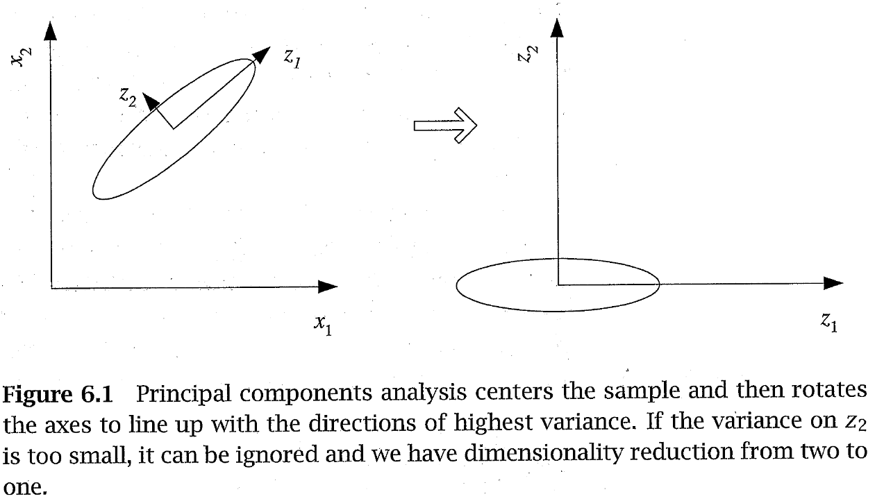

## PCA overview

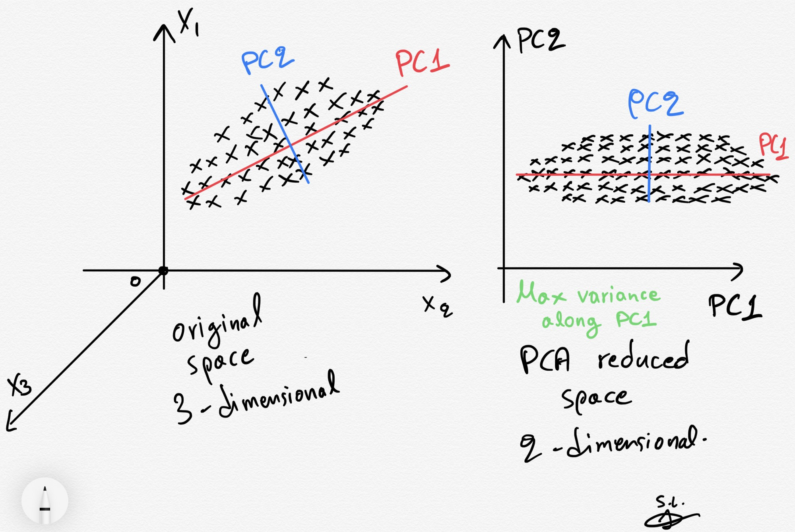

<https://towardsdatascience.com/>

# Evaluation| Supervised learning | Which method to use?

## Data Splitting

* Training set
  + Validation set (dev set)
    - A validation dataset is a dataset of examples used to tune the hyperparameters (i.e. the architecture) of a classifier. It is sometimes also called the development set or the “dev set”.
* Test set

## Cross Validation

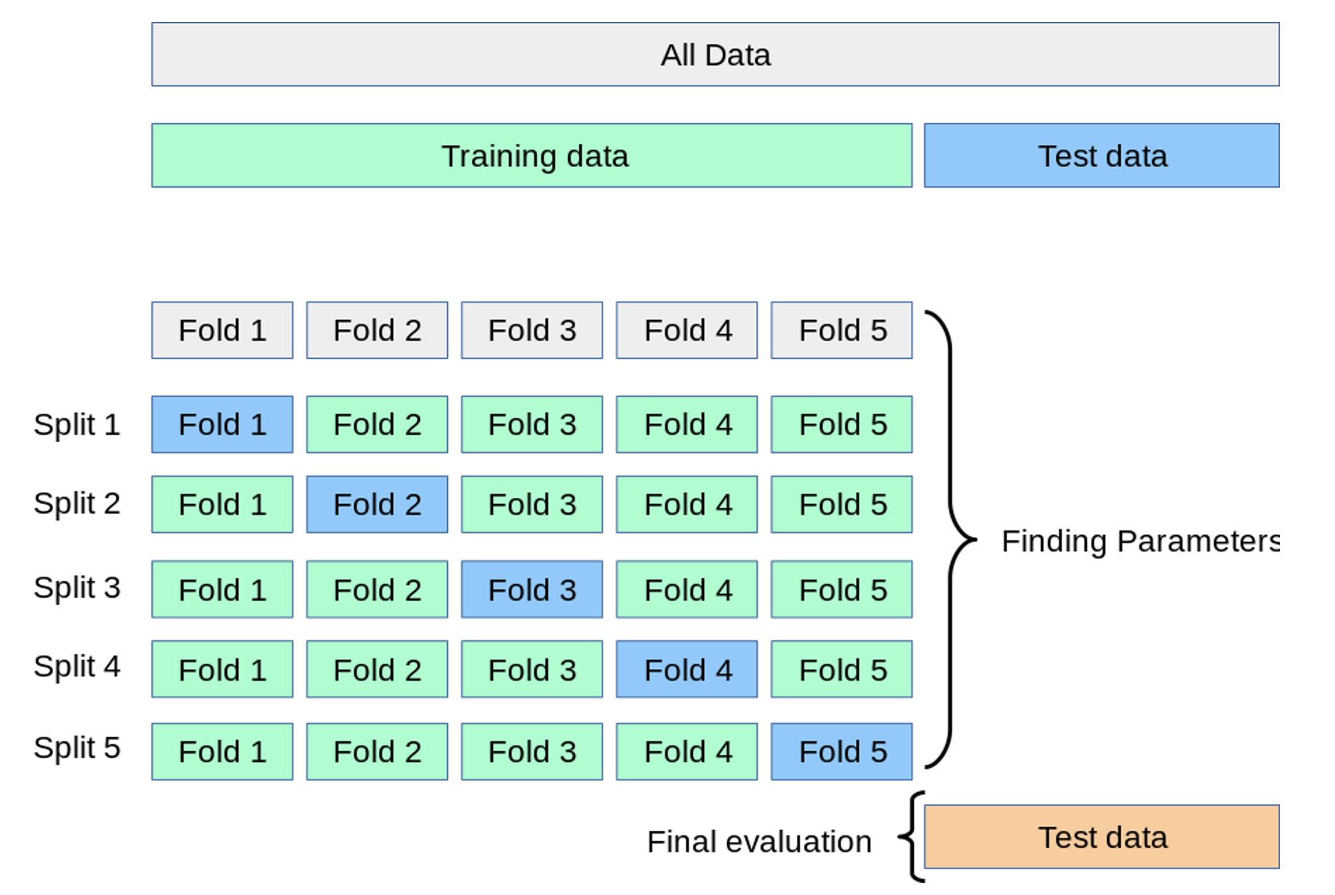

<https://scikit-learn.org/stable/modules/cross_validation.html>

## Confusion matrix

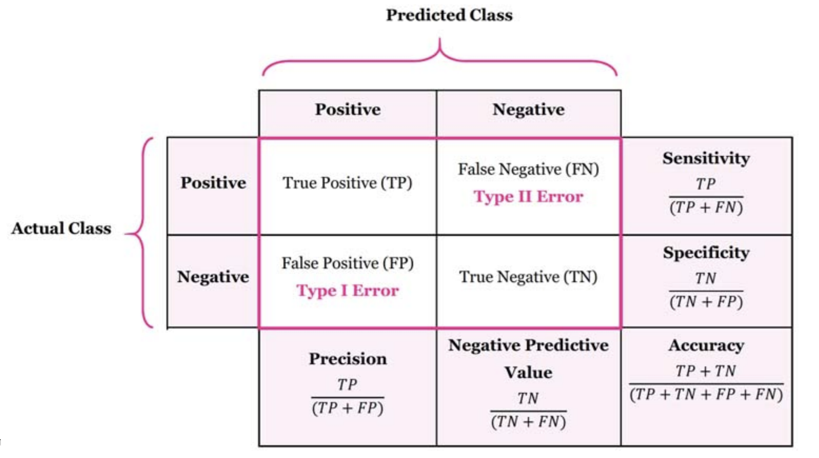

## Accuracy

* What proportion of instances is correctly classified?
* TP + TN / TP + FP + FN + TN
* Accuracy is a valid choice of evaluation for classification problems which are well balanced and not skewed.
* Let us say that our target class is very sparse. Do we want accuracy as a metric of our model performance? What if we are predicting if an asteroid will hit the earth? Just say “No” all the time. And you will be 99% accurate. The model can be reasonably accurate, but not at all valuable.

## Precision and recall

* Precision: % of selected items that are correct Recall: % of correct items that are selected
* Precision is a valid choice of evaluation metric when we want to be very sure of our prediction.
* Recall is a valid choice of evaluation metric when we want to capture as many positives as possible.

## A combined measure: F

A combined measure that assesses the P/R tradeoff is F measure (weighted harmonic mean):

$$F=\frac{1}{α\frac{1}{P}+(1−α)\frac{1}{R}}=\frac{(β^{2}+1)PR}{β^{2}P+R}$$

The harmonic mean is a very conservative average;

Balanced F1 measure - i.e., with $β=1$ (that is, $α=1/2$): $F=2PR/(P+R)$

# Summary

## Summary

* Feature selection for text
* Different methods
* Can be quite effective!

# Time for Practical 3!